**ADVANCE CODING ASSIGNMENT-1**

**T. BHAGATH**

**VU21CSEN0300254**

1. **Write a C program to calculate sum of digits of a number.**

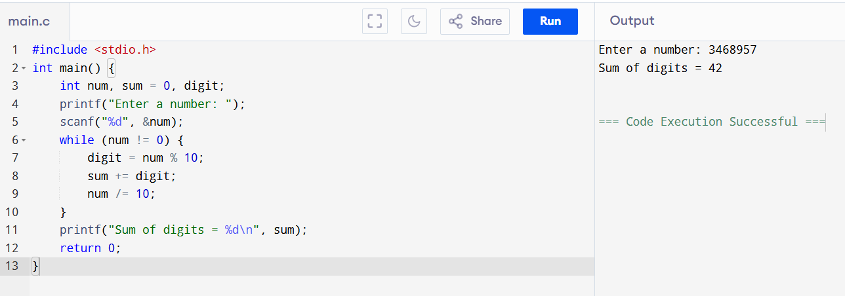

1. **Write a C program to find first and last digit of a number.**

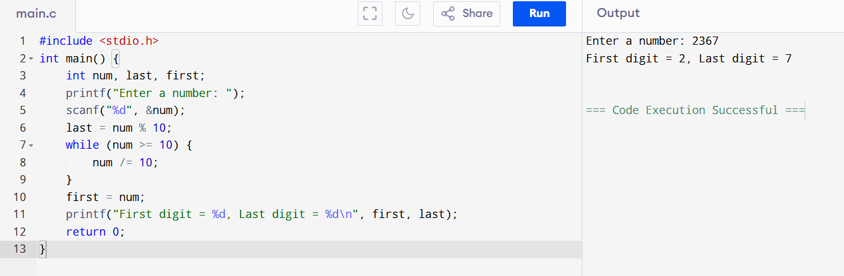

1. **Write a C program to find sum of first and last digit of a number.**

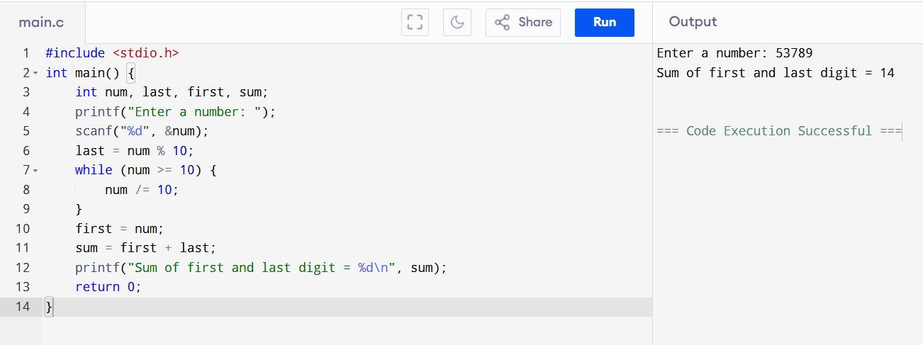

1. **Write a C program to swap first and last digits of a number.**

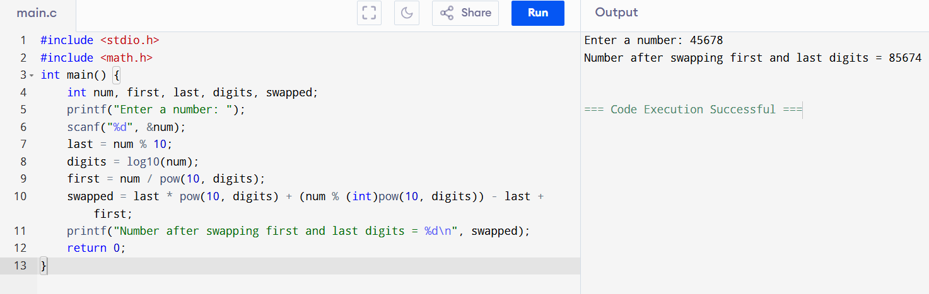

1. **Write a C program to find frequency of each digit in a given integer.**

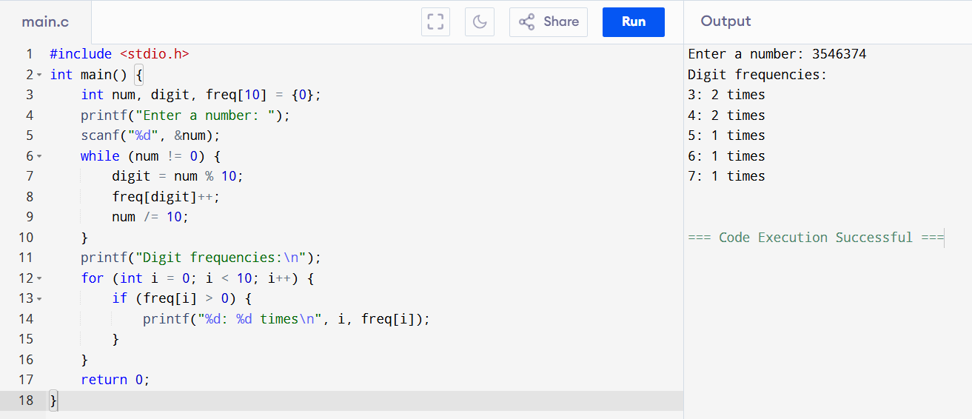

1. **Write a C program to enter a number and print it in words.**

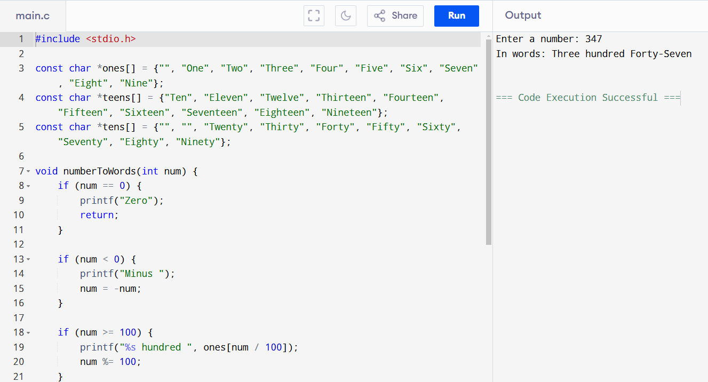

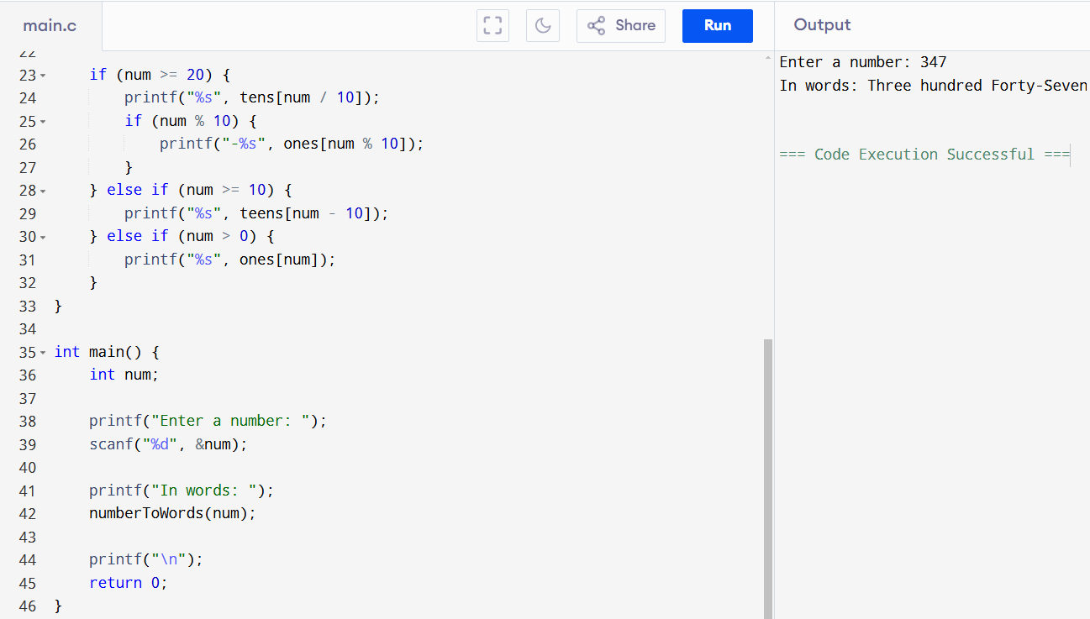

1. **Write a C program to find one’s complement of a binary number.**

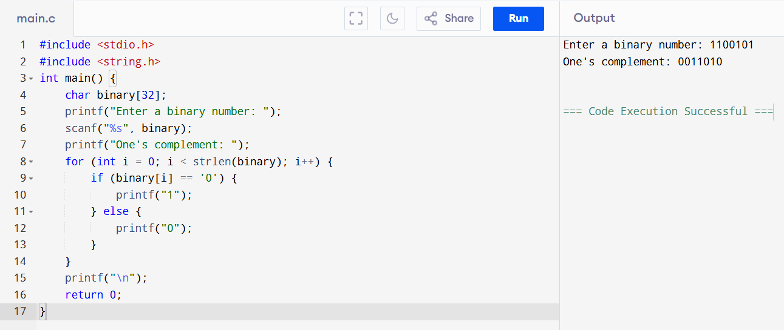

1. **Write a C program to find two’s complement of a binary number.**

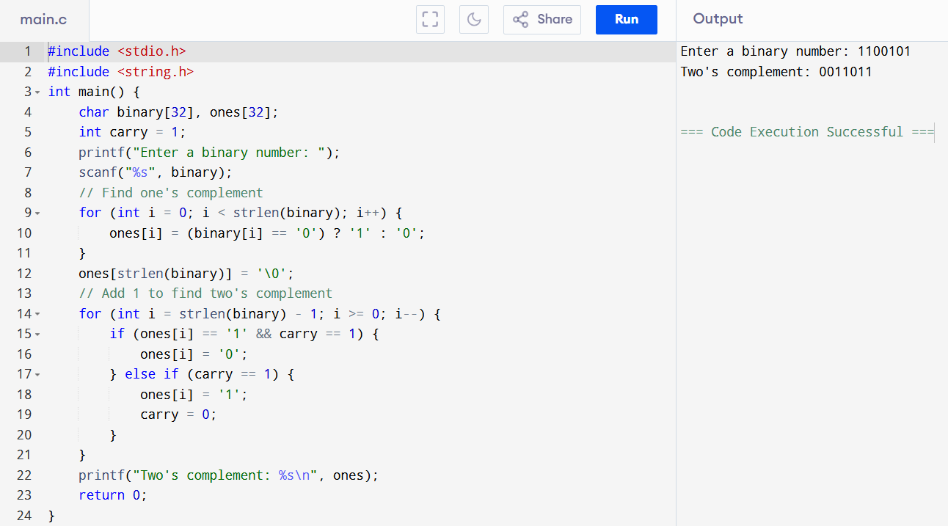

1. **Write a C program to convert Decimal to Hexadecimal number system.**

